Analyse mit Exomiser:

## yml Datei erstellen mit Pfad zur ped, vcf, proband sample name und phänotypen

## Exomiser Analysis Template.

# These are all the possible options for running exomiser. Use this as a template for

# your own set-up.

---

analysis:

**ped: /PATH/TO/PED**

**proband: PROAND_SAMPLE_NAME**

**vcf: /PATH/TO/VCF**

# AUTOSOMAL_DOMINANT, AUTOSOMAL_RECESSIVE, X_RECESSIVE or UNDEFINED

inheritanceModes: {

AUTOSOMAL_DOMINANT: 0.1,

AUTOSOMAL_RECESSIVE_HOM_ALT: 3.0,

AUTOSOMAL_RECESSIVE_COMP_HET: 5.0,

X_DOMINANT: 0.1,

X_RECESSIVE_HOM_ALT: 3.0,

X_RECESSIVE_COMP_HET: 5.0,

}

#FULL, SPARSE or PASS_ONLY

analysisMode: PASS_ONLY

#hpoIds: ['HP:0100280']

hpoIds: []

#Possible frequencySources:

#Thousand Genomes project http://www.1000genomes.org/

# THOUSAND_GENOMES,

#ESP project http://evs.gs.washington.edu/EVS/

# ESP_AFRICAN_AMERICAN, ESP_EUROPEAN_AMERICAN, ESP_ALL,

#ExAC project http://exac.broadinstitute.org/about

# EXAC_AFRICAN_INC_AFRICAN_AMERICAN, EXAC_AMERICAN,

# EXAC_SOUTH_ASIAN, EXAC_EAST_ASIAN,

# EXAC_FINNISH, EXAC_NON_FINNISH_EUROPEAN,

# EXAC_OTHER

frequencySources: [

THOUSAND_GENOMES,

TOPMED,

UK10K,

ESP_AFRICAN_AMERICAN, ESP_EUROPEAN_AMERICAN, ESP_ALL,

EXAC_AFRICAN_INC_AFRICAN_AMERICAN, EXAC_AMERICAN,

EXAC_SOUTH_ASIAN, EXAC_EAST_ASIAN,

EXAC_FINNISH, EXAC_NON_FINNISH_EUROPEAN,

EXAC_OTHER,

GNOMAD_E_AFR,

GNOMAD_E_AMR,

# GNOMAD_E_ASJ,

GNOMAD_E_EAS,

GNOMAD_E_FIN,

GNOMAD_E_NFE,

GNOMAD_E_OTH,

GNOMAD_E_SAS,

GNOMAD_G_AFR,

GNOMAD_G_AMR,

# GNOMAD_G_ASJ,

GNOMAD_G_EAS,

GNOMAD_G_FIN,

GNOMAD_G_NFE,

GNOMAD_G_OTH,

GNOMAD_G_SAS

]

#Possible pathogenicitySources: POLYPHEN, MUTATION_TASTER, SIFT, CADD, REMM

#*WARNING* if you enable CADD, ensure that you have downloaded and installed the CADD tabix files

#and updated their location in the application.properties. Exomiser will not run without this.

pathogenicitySources: [POLYPHEN, MUTATION_TASTER, SIFT]

#this is the standard exomiser order.

#all steps are optional

steps: [

#intervalFilter: {interval: 'chr10:123256200-123256300'},

#genePanelFilter: {geneSymbols: []},

#failedVariantFilter: {},

qualityFilter: {minQuality: 20.0},

variantEffectFilter: {remove: [UPSTREAM_GENE_VARIANT,

INTERGENIC_VARIANT,

NON_CODING_TRANSCRIPT_INTRON_VARIANT,

SYNONYMOUS_VARIANT,

DOWNSTREAM_GENE_VARIANT]},

#knownVariantFilter: {}, #removes variants represented in the database

frequencyFilter: {maxFrequency: 5.0},

pathogenicityFilter: {keepNonPathogenic: true},

#inheritanceFilter and omimPrioritiser should always run AFTER all other filters have completed

#they will analyse genes according to the specified modeOfInheritance above- UNDEFINED will not be analysed.

inheritanceFilter: {},

#omimPrioritiser isn't mandatory.

omimPrioritiser: {},

#priorityScoreFilter: {minPriorityScore: 0.4},

#Other prioritisers: Only combine omimPrioritiser with one of these.

#Don't include any if you only want to filter the variants.

hiPhivePrioritiser: {},

# or run hiPhive in benchmarking mode:

#hiPhivePrioritiser: {runParams: 'mouse'},

#phivePrioritiser: {}

#phenixPrioritiser: {}

#exomeWalkerPrioritiser: {seedGeneIds: [11111, 22222, 33333]}

]

outputOptions:

outputPassVariantsOnly: false

#numGenes options: 0 = all or specify a limit e.g. 500 for the first 500 results

numGenes: 0

#outputPrefix options: specify the path/filename without an extension and this will be added

# according to the outputFormats option. If unspecified this will default to the following:

# {exomiserDir}/results/input-vcf-name-exomiser-results.html

# alternatively, specify a fully qualifed path only. e.g. /users/jules/exomes/analysis

outputPrefix: analysis/results

#out-format options: HTML, TSV-GENE, TSV-VARIANT, VCF (default: HTML)

outputFormats: [TSV-GENE, TSV-VARIANT, VCF, HTML]

## Starten des Durchlaufs

Auf dem cluster mit:

module load IKMB Java/1.8.0 && sbatch --exclude=rzcl236 -p ikmb_a --qos ikmb_a -J exomiser --mem=16G -t 2:0:0 --wrap="java -Xms8g -Xmx16g -jar /ifs/data/nfs_share/ikmb_repository/software/exomiser/10.0.0/exomiser-cli-10.0.0.jar --analysis analysis/config_exomiser.yml"

## Ausführen von run_pipieline.py

Parameter:

exomiser_path = '/Users/broder/projects/IBD-DACH_FT_3/exomiser/analysis'

annovar_path = '/Users/broder/projects/IBD-DACH_FT_3/variants.merged.normalized.vcf.gz.annovar.hg19_multianno.txt'

output_path = '/Users/broder/projects/IBD-DACH_FT_3/result.tsv'

- Merged die Varianten von den verschiedenen Exomiser Inheritance Dateien zusammen

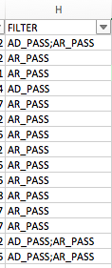

- Wendet die verschiedenen Genlisten auf die Varianten an

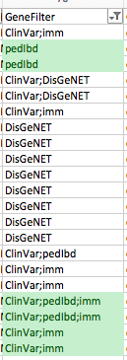

- Fügt die AnnoVar Annotation für jede Variante hinten an die Exomiser Outputdatei

## Kopieren der Ergebnisse in das Result Template

## Filtern

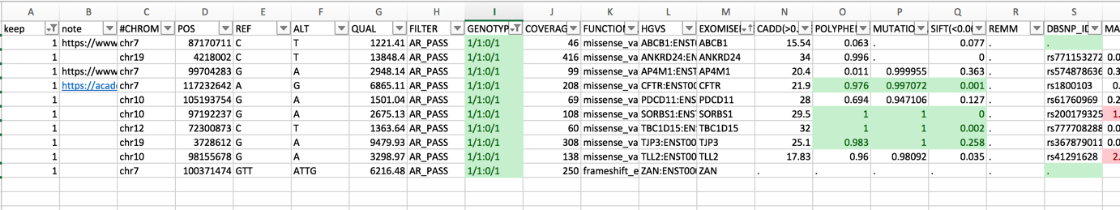

## Extrahieren der gefilterten Varianten zu einem vcf

Sub toVcf()

Dim sh As Worksheet

Dim rw As Range

Dim keep As Integer

outputFile = FreeFile

Open "/Users/broder/tmp/vcf_output.vcf" For Output As #outputFile

Print #outputFile, "#CHROM" & vbTab & "POS" & vbTab & "ID" & vbTab & "REF" & vbTab & "ALT" & vbTab & "QUAL" & vbTab & "FILTER" & vbTab & "INFO"

Set sh = ActiveSheet

start = 3

For Each rw In sh.Rows

If sh.Cells(rw.Row, 1).Value = "1" Then

chromTmp = sh.Cells(rw.Row, start).Value

chrom = Replace(chromTmp, "chr", "")

pos = sh.Cells(rw.Row, start + 1).Value

Id = sh.Cells(rw.Row, start + 16).Value

ref = sh.Cells(rw.Row, start + 2).Value

alt = sh.Cells(rw.Row, start + 3).Value

qual = sh.Cells(rw.Row, start + 4).Value

filterVal = sh.Cells(rw.Row, start + 5).Value

info = "."

Print #outputFile, chrom & vbTab & pos & vbTab & Id & vbTab & ref & vbTab & alt & vbTab & qual & vbTab & filterVal & vbTab & info

ElseIf sh.Cells(rw.Row, start).Value = "" Then

Exit For

End If

Next rw

Close #outputFile

End Sub

-> Einstellen in VarWatch